

Ms. G. Mamatha
PERUGU MANISHA
2520030054
CSE
CO2 B+Trees,B-Trees,Fenwick Trees,Segment Trees

Case Study Topic :Airline Reservation Database Indexing and Passenger Analytics using B+ Trees and Fenwick Trees
Work Done Summary
In this case study, we implemented B-Tree, B+ Tree, Segment Tree, and Fenwick Tree concepts for airline reservation and passenger analytics systems.
B-Tree and B+ Tree were used for flight reservation database indexing and efficient record retrieval. Fenwick Tree was used to calculate passenger booking totals quickly, while Segment Tree was analyzed for range-based flight occupancy queries.
The structures were compared based on search efficiency, storage optimization, and query performance. The study concluded that B+ Trees are best suited for airline database indexing, while Fenwick Trees are effective for passenger count analytics and cumulative booking queries.

Implementation Details
B-Tree
- Inserted flight reservation records into a multi-way search tree.
- Allowed multiple keys per node.
- Reduced tree height compared to BST.
- Supported efficient disk-based indexing.
B+ Tree
- Stored reservation records in leaf nodes.
- Connected leaf nodes using linked traversal.
- Enabled efficient range searches.
- Used for airline reservation database indexing.
Fenwick Tree
- Maintained passenger booking counts.
- Supported prefix sum queries.
- Updated booking counts dynamically.
- Reduced query complexity.
Segment Tree
- Performed range occupancy analysis.
- Supported interval queries.
- Handled flight seat utilization calculations.
- Compared against Fenwick Tree performance.

Result :Screenshots / Output
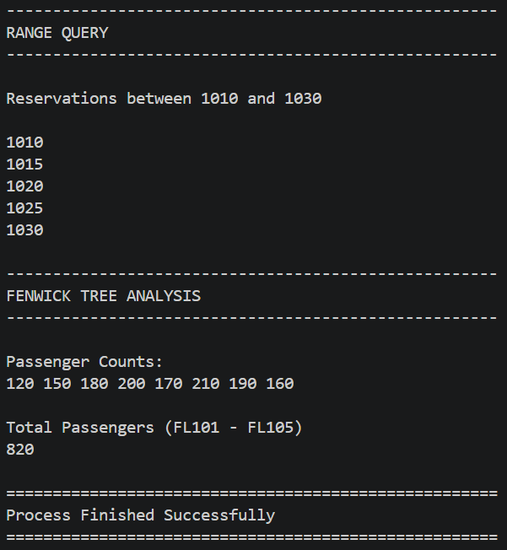
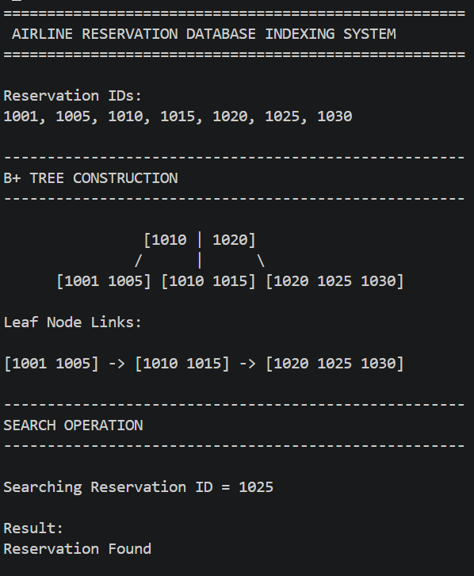

Time Complexity Analysis
Operation | B-Tree | B+ Tree | Segment Tree | Fenwick Tree
Search | O(log n) | O(log n) | - | -
Insert | O(log n) | O(log n) | - | O(log n)
Range Query | O(log n + k) | O(log n + k) | O(log n) | O(log n)
Update | O(log n) | O(log n) | O(log n) | O(log n)

Conclusion
The study demonstrated the application of B-Trees, B+ Trees, Segment Trees, and Fenwick Trees in airline reservation and analytics systems. B+ Trees proved most suitable for airline database indexing because of efficient range retrieval and disk access optimization. Fenwick Trees provided fast passenger count aggregation and update operations. These structures are widely used in airline reservation systems, airport databases, and flight analytics platforms.

GITHUB LINK: https://github.com/manishaperugu49-glitch/2520030054-DSA_2_CaseStudy_CO2

